**A1 Report**

Name: Tan Jun Yong, Joben

UOW ID: 8065354

**2D Scene:**

Code used to draw the truck:

Explanation:

I drew the base first, which consist of 2 triangles, then the driver compartment, followed by the window, then the bottom cargo area and then the upper cargo area, and lastly is the wheels. I use 3x Vertex2f to put 3 coordinates for the triangle to make the whole truck.

For color wise, using two coordinates for one color and 1 coordinate for another color to achieve the gradient effect.

**Transformations and Keyboard input:**

Code for keyboard input:

Explanation:

It takes in keyboard arrow keys input, so when left arrow key is pressed, the coordinates +10 or – 10 every loop/frame and vice versa.

Truck transformation:

Explanation:

For this calculation, it takes in the angle and multiplies a predefined speed, so the higher the angle, the faster the truck rolls

Rotate the wheels:

Explanation:

For this calculation, similar to the truck transformation above, it takes the value of the truck previous frame, and subtract with the value of the truck position in the current frame, to find the distance, and rotate at an angle in regards to the outer wheel radius.

Based on this formula:

*ϕ*new​=(*ϕ*old​−((*x*current​−*x*previous​)⋅cos(*θ*))⋅(2*πr*360∘​))mod360∘

**User Interface:**

Toggling wireframe:

Code:

Change background:

Code:

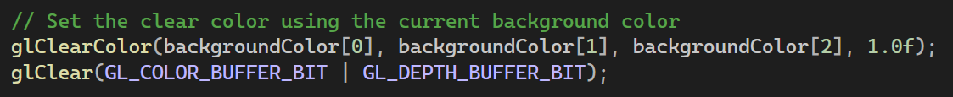

Background color is updated in the main loop every loop.

Change ground slope:

Code:



UI:

Code to calculate framerate:

Explanation:

The code that multiplies by 1000 is to convert the delta time seconds into milliseconds.

And as for frame rate, the 1 stands for 1 second, which divides by how many completed image can it generate before the 1s mark.